**CI 245 Final Project Proposal**

Due emailed to instructor by 9:50 pm 11/14/2019

five-point loss on final project for each day late thereafter

this proposal can continue for as many pages as it needs to

Student 1 Name: Kimberly Arnett

Student 2 Name: Joshua Myers

Student 3 Name: Ryan T. Moran

**Instructor reserves the right to modify teams (move people, pair people together) to ensure student success.**

Title of Project: Memory Match

Narrative Description:

The proposed game is an implementation of the classic memory-matching game. The game will dynamically and randomly load a determined number of face-down images, predicated on the user’s choice of difficulty (grid size). Determinant of the choice of difficulty, the addition of a count-down feature will be considered.  
  
A guess count will be accrued until the successful matching of all image items. High scores (lowest guess count) will be persistently recorded using local file serialization.  
  
Possibility of implementing an impossible mode, in which, remaining unmatched image items will be regularly reshuffled at the interval of every 15/30 seconds.

Key Features:

1) The user will be able to set the difficulty of the game by selecting the dimensions of the grid.

2) If the user makes a correct match, a message stating so will be shown. If the user is incorrect, there will be a message prompting the user to try again.

3) The game will keep track of the users best score as in their lowest number of guesses.

Sketch of Graphical User Interface:

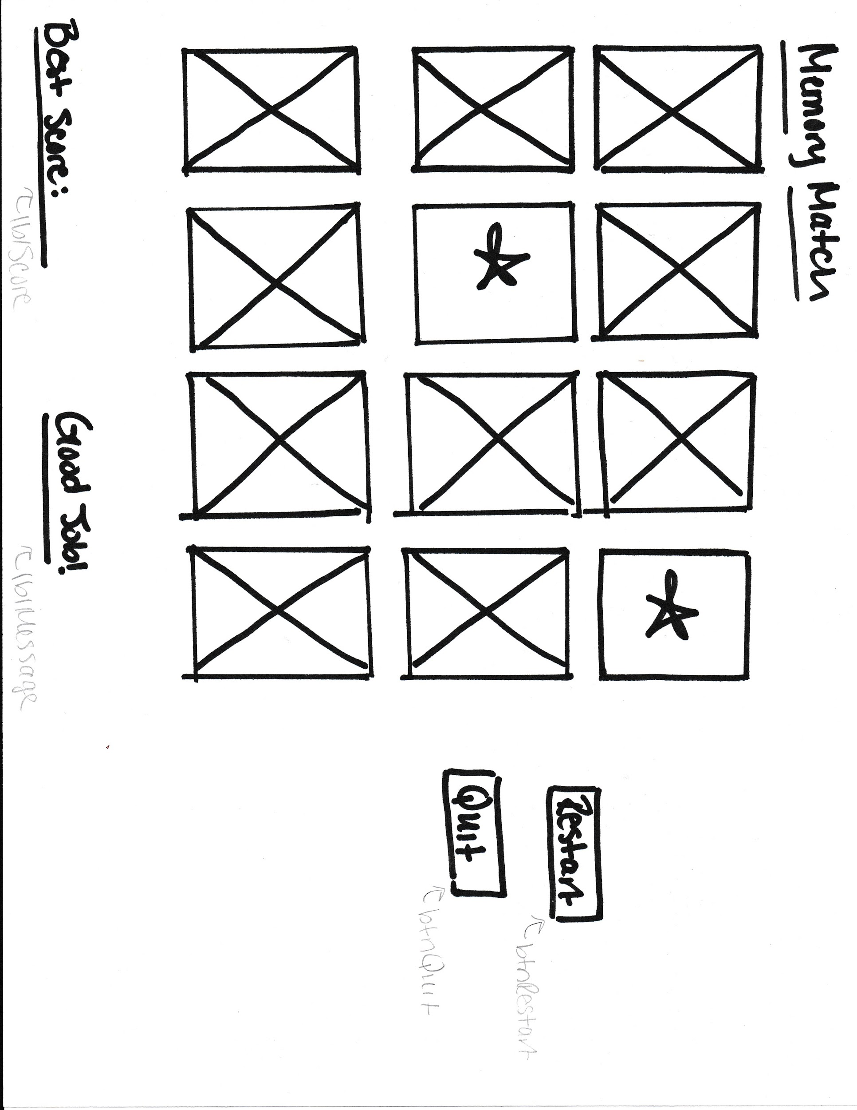

Distribution of Workload:

1) Kimberly will work on designing the GUI and will help with the programming.

2) Joshua will work on the programming and help with GUI, unsure what specifically though yet.

3) Implement back-end logic.